Climate Change Threatens the Biodiversity of the World’s Marine Protected Areas

John F. Bruno1, Amanda E. Bates2, Chris Cacciapaglia3, Elizabeth P. Pike4, Steven Amstrup5, Ruben van Hooidonk6,7, Stephanie A. Henson8, and Richard B. Aronson3

1 Department of Biology, The University of North Carolina at Chapel Hill, Chapel Hill, NC 27599-3280, USA

2 Ocean and Earth Science, National Oceanography Centre Southampton, University of Southampton, Southampton SO14 3ZH, UK

3Department of Biological Sciences, Florida Institute of Technology, 150 West University Boulevard, Melbourne, FL, USA 32901

4 Marine Conservation Institute, Seattle, WA, USA 98103

5 Polar Bears International, P.O. Box 3008, Bozeman, MT, USA 59772

6 NOAA Atlantic Oceanographic and Meteorological Laboratory, Ocean Chemistry and Ecosystems Division, 4301 Rickenbacker Causeway, Miami, FL 33149, USA

7 Cooperative Institute for Marine and Atmospheric Studies, Rosenstiel School of Marine and Atmospheric Science, University of Miami, 4600 Rickenbacker Causeway, Miami, FL 33149, USA

8 National Oceanography Centre, Southampton, SO14 3ZH, UK

**Marine Protected Areas (MPAs)—coastal and open-ocean nature preserves—are a primary management tool for mitigating local threats to marine biodiversity**1**. MPAs and the species they protect, however, have been and increasingly will be impacted by anthropogenic climate change, raising questions about whether they can serve their intended purpose in a warming world. Here we show that, despite local protections, the warming associated with continued business-as-usual (BAU) emissions (RCP8.5)**2 **will result in habitat and species losses throughout low-latitude and tropical MPAs**3,4**. With unabated BAU emissions, mean sea-surface temperatures (SST) within MPAs will increase 0.034 °C/year and warm an additional 2.8 °C by 2100. We determined the time of emergence (the year when sea surface temperature and oxygen concentration exceed their ranges of natural variability) for 309 no-take marine reserves, showing that with continued BAU emissions, both factors “emerge” by mid-century in 42% of reserves. Moreover, we show the spatial distribution of emergence is stressor-specific. Hence, rearranging MPAs to minimize exposure to one factor could well increase exposure to another. Continued BAU emissions, therefore, will likely disrupt the species and ecosystems and offset the purported benefits of MPA protections.**

Species dependent on marine reserves could be especially sensitive to anthropogenic climate change because of their typically small populations, restricted geographic ranges, and low genetic diversities5. Case studies indicate that global-warming-induced climate changes already are having substantial effects on populations and ecosystems otherwise protected within terrestrial and marine reserves6,7. Gradual warming over the last several decades and unusually high seawater temperatures in early 2016, for example, caused mass coral mortality across much of the northern Great Barrier Reef (GBR), a UNESCO World Heritage Site and model MPA8. Despite its isolation and effective protection from harvesting, pollution, and other stressors, warming radically altered the northern GBR. This and similar case studies, as well as synthetic analysis9, call into question the long-term effectiveness of MPAs in protecting their resident biotas in the face of climate change.

Anthropogenic carbon emissions lead to acute and chronic perturbations including increasing storm intensity, rising sea levels, altered upwelling regimes, ocean acidification, and deoxygenation10,11. As a result, organisms must simultaneously adjust their physiologies to cope with multiple threats that in some cases could be selecting for opposing traits. We focused on two critical effects influencing MPAs: rising temperatures and changing oxygen concentrations. The oceans are absorbing over 90% of the additional heat being trapped by anthropogenic greenhouse gases, causing increases in ocean temperature even in the deep sea12. We asked how much the world’s MPAs can be expected to warm and lose oxygen under the business-as-usual emissions trajectory RCP 8.5 and the RCP 4.5 mitigation scenario, for which emissions peak around 2040 and CO2 concentration stabilizes at ~525 ppm in 2100(ref. 2). We used CMIP5 models to predict the mean 21st century rate of change in SST and O2 at the geographic centers of 8236 MPAs around the world (Fig. 1A). We also assessed warming rates in 309 no-take reserves, in which fishing is banned. With BAU emissions, mean SSTs are predicted to increase within nearly all MPAs: the average warming rate is 0.034 °C/year (Table 1), with a maximum increase of 0.113°C/year in northern Baffin Bay off northwest Greenland. This predicted future warming continues the trend of recent anthropogenic warming of 0.1 °C per decade on average since 196013. Projected warming rates increase slightly with latitudinal zone, from the tropics to polar oceans (Tables 1, S1). Remarkably, under RCP 8.5, 99% of the world’s MPAs are forecasted to warm ≥2°C by 2100. The RCP 4.5 mitigation scenario predicts substantially lower warming rates (Table 1), and thus presumably reduced impacts on marine organisms10,11.

The effects of ocean warming on marine species and ecosystems, which are already well-documented14, would likely increase if the rates of warming under RCP 8.5 are realized. Several recent studies have combined projected warming, species-specific thermal tolerances, and patterns of species distribution to predict changes in species richness and composition in response to ocean warming. For example, Stuart-Smith et al.3 predicted that nearly 100% of extant species will be excluded from many tropical reef communities by 2115 under RCP 8.5. Likewise, Molinos et al.4 predicted drastic declines in the regional species pools of tropical marine communities and substantial increases in temperate communities, accompanied by changes in species composition. These responses are driven by populations tracking the geographic movement of their thermal niches and shifting their ranges, generally to higher latitudes. In mid- to high-latitude ecosystems, shifts in species composition will likely lead to changes in species interactions and food-web dynamics, losses of foundation species such as kelps, and invasions of new predators, competitors, and parasites14,15. In contrast, as tropical communities cross their thermal thresholds, the primary outcome is expected to be biodiversity loss, as there are no climate change induced-migrants to colonize from warmer regions. Thus, ocean warming will have fundamentally different impacts on the biota currently protected in tropical and temperate MPAs. Finally, due to temperature-dependent metabolism of fishes and invertebrates, which are ectotherms, warming will have strong, non-lethal effects on a wide array of population-, community-, and ecosystem-level processes including developmental and dispersal rates, species interactions, and the standing biomass of plants and animals16,17. Not all of these effects will be realized in every reserve. For example, individuals can acclimatize to a degree, and populations can adapt to warming. However, there are limits to the scope and rate of both acclimatization and adaptation that vary with phylogenetic history, life history, and other biological attributes. Moreover, anthropogenic warming is occurring far more rapidly than natural warming has over the last 65 million years18.

Under RCP 8.5, by 2050 trends in warming and deoxygenation, as well as declining pH, exceed background variability over 86% of the ocean10. Assuming organisms are adapted to local environmental conditions, this degree of change of multiple factors that strongly affect their metabolism and fitness, and largely define their fundamental niches, would likely cause local extinctions and changes in species composition. We considered this emergence point—the exceedance of natural variability—to be a loose threshold for population and community responses to climate change10. We calculated the year of emergence (i.e., the timing of exceedance) of warming and deoxygenation for no-take marine reserves at different latitudes (Fig. 2). Under RCP 8.5, both stressors emerge by mid-century in 42% of no-take zones (pH emerged in all marine reserves decades ago, Fig. S1).Deoxygenation, caused by warming and increasing shallow-water stratification, is predicted to affect primary production and a variety of physiological and geochemical processes19. Moreover, warming and deoxygenation can impact organisms synergistically because warming decreases oxygen concentration while increasing the metabolism and oxygen demand of ectotherms (e.g., fishes and invertebrates). Unlike deoxygenation (Fig. 2B), the year of emergence for temperature was later by decades for high-latitude reserves (Fig. 2A, but note there is substantial variation at a given latitude). In fact, temperature has already exceeded background variability for many tropical reserves.

Warming rates are projected to be relatively modest in some marine ecoregions20, including many around Australia and New Zealand, and more rapid in others, such as the Western Mediterranean and South Orkney Islands (Table S1). However, the substantial variation in the inherent thermal sensitivity of constituent species among ecoregions (i.e., thermal bias3), complicates predictions and comparison of regional and local impacts of warming. The margin between what a species can tolerate and local maximum temperatures, averaged across all species in a community, is the “Community Thermal Safety Margin” (CTSM, Fig. 2C). Exceeding the CTSM means that maximum summertime temperatures exceed the estimated tolerance for the average species within the community. In theory, this will cause the loss of a substantial number of species, even with a reasonable degree of adaptation or acclimatization. Based on predicted warming under RCP 8.5, for many tropical ecoregions the CTSM will be exceeded by ~2050 but not until ~2150 at temperate latitudes.

One potential management response to anthropogenic warming is to position reserves within regions expected to warm less or not at all, in climate change refugia21,22. However, forecasted warming rates for MPAs roughly match mean background rates; MPAs are warming at the same rate as unprotected areas, except in polar regions (Table 2). At a smaller scale, we found that there is substantial variation among ecoregions in projected warming (Table S1) but that MPA placement has not been focused on ecoregions with lower rates (Fig. S2). Even if future MPAs are better positioned in regard to projected warming, the distribution of other important climate-change stressors such as deoxygenation is spatially discordant with that of temperature (Fig. 3). Locations for which SST emerges after 2050 under RCP 8.5 are primarily in the Southern Ocean, whereas refugia from deoxygenation are mainly tropical (Fig. 3); however, only 3.5 % of existing MPAs overlap with multi-factor refugia (Fig. 3).

Marine biodiversity is already being degraded by numerous stressors unrelated to carbon emissions such as fishing, habitat loss, and pollution. Populations of marine vertebrates, especially predators, have been reduced by 50 to 95% in most oceanic regions23, and habitat-forming species such as seagrasses, mangroves, and corals are declining by roughly 1% annually24–26. Although not a panacea, well-enforced MPAs, particularly no-take marine reserves, effectively mitigate some of these threats and partially restore marine biodiversity27,28. A recent meta-analysis found that to meet the biodiversity and fisheries goals of MPAs, global coverage needs to be increased from 3% of ocean surface area to 30% or greater29. We support the rapid expansion of fully-protected MPAs and other forms of local conservation such as marine spatial planning, with the critical caveat that local protection is necessary but insufficient to conserve and restore marine biota1. Although MPAs are widely-promoted as a means to mitigate the effects of climate change30, the opposite perspective is more in line with the scientific reality: without drastic reductions in carbon emissions, ocean warming, acidification, and oxygen depletion in the 21st century will in all likelihood disrupt the composition and functioning of the ecosystems currently protected within the world’s MPAs. The community- and ecosystem-level impacts of climate change threaten to negate decades of progress in conservation and further imperil species and ecosystems that are already in great peril.

**Supplementary Information** is available in the online version of the paper.

**Acknowledgements** We thank Mark Ruddy for assistance with coding and data analysis, and for preparing Figure 1. This research was supported by the U.S. National Science Foundation (OCE-1535007 to R.B.A.). This is contribution ZZZ from the Institute for Research on Global Climate Change at the Florida Institute of Technology.

**Author Contributions** J.F.B. and R.B.A. conceived the study. J.F.B., A.E.B., C.C, and S.A.H. performed the analysis. J.F.B. A.E.B., S.A.H. and R.B.A. interpreted the results. J.F.B. and R.B.A. wrote the manuscript, with substantial assistance from the other authors. A.E.B., E.P.P., R.v.H., and S.A.H. provided datasets.

**Author Information** Reprints and permissions information is available at www.nature.com/reprints. The authors declare no competing financial interests. Readers are welcome to comment on the online version of the paper. Publisher’s note: Springer Nature remains neutral with regard to jurisdictional claims in published maps and institutional affiliations. Correspondence and requests for materials should be addressed to J.F.B. (jbruno@unc.edu).

**Reviewer Information** *Nature* thanks the anonymous reviewer(s) for their contribution to the peer review of this work.

**Literature Cited**

1. Allison GW, Lubchenco J, Carr MH. Marine reserves are necessary but not sufficient for marine conservation. *Ecol Appl*. 1998;8(1 SUPPL.):79-92. doi:10.1890/1051-0761(1998)8[S79:MRANBN]2.0.CO;2.

2. van Vuuren DP, Edmonds J, Kainuma M, et al. The representative concentration pathways: An overview. *Clim Change*. 2011;109(1):5-31. doi:10.1007/s10584-011-0148-z.

3. Stuart-Smith RD, Edgar GJ, Barrett NS, Kininmonth SJ, Bates AE. Thermal biases and vulnerability to warming in the world’s marine fauna. *Nature*. 2015;528(7580):88-92. doi:10.1038/nature16144\rhttp://www.nature.com/nature/journal/v528/n7580/abs/nature16144.html#supplementary-information.

4. García Molinos J, Halpern BS, Schoeman DS, et al. Climate velocity and the future global redistribution of marine biodiversity. *Nat Clim Chang*. 2015;6(1):83-88. doi:10.1038/nclimate2769.

5. Peters RL, Darling JDS. The greenhouse effect and nature reserves. *Bioscience*. 1985;35(11):707-717. doi:10.2307/1310052.

6. Graham N a J, McClanahan TR, MacNeil MA, et al. Climate warming, marine protected areas and the ocean-scale integrity of coral reef ecosystems. *PLoS One*. 2008;3(8):e3039. doi:10.1371/journal.pone.0003039.

7. Monahan WB, Fisichelli NA. Climate exposure of US national parks in a new era of change. *PLoS One*. 2014;9(7):e101302.

8. Hughes TP, Kerry J, Álvarez-Noriega M, et al. Global warming and recurrent mass bleaching of corals. *Nature*. 2017. doi:10.1038/nature21707.

9. Selig ER, Casey KS, Bruno JF. Temperature-driven coral decline: the role of marine protected areas. *Glob Chang Biol*. February 2012:n/a-n/a. doi:10.1111/j.1365-2486.2012.02658.x.

10. Henson SA, Beaulieu C, Ilyina T, et al. Rapid emergence of climate change in environmental drivers of marine ecosystems. *Nat Commun*. 2017;8(5020):14682. doi:10.1038/ncomms14682.

11. Gattuso J-P, Magnan A, Bille R, et al. Contrasting futures for ocean and society from different anthropogenic CO2 emissions scenarios. *Science (80- )*. 2015;349(6243):aac4722-1-aac4722-10. doi:10.1126/science.aac4722.

12. Gleckler PJ, Durack PJ, Stouffer RJ, Johnson GC, Forest CE. Industrial-era global ocean heat uptake doubles in recent decades. *Nat Clim Chang*. 2016;6(4):394-398. doi:10.1038/nclimate2915.

13. Burrows MT, Schoeman DS, Buckley LB, et al. The pace of shifting climate in marine and terrestrial ecosystems. *Science (80- )*. 2011;334(6056):652-655. doi:10.1126/science.1210288.

14. Poloczanska ES, Brown CJ, Sydeman WJ, et al. Global imprint of climate change on marine life. *Nat Clim Chang*. 2013;3(10):919-925. doi:10.1038/nclimate1958.

15. Aronson RB, Thatje S, Clarke A, et al. Climate Change and Invasibility of the Antarctic Benthos. *Annu Rev Ecol Evol Syst*. 2007;38(1):129-154. doi:10.1146/annurev.ecolsys.38.091206.095525.

16. Bruno JF, Carr LA, O’Connor MI. Exploring the role of temperature in the ocean through metabolic scaling. *Ecology*. 2015;96(12):3126-3140. doi:10.1890/14-1954.1.

17. Svensson F, Karlsson E, G\a ardmark A, et al. In situ warming strengthens trophic cascades in a coastal food web. *Oikos*. 2017:In press.

18. Diffenbaugh NS, Field CB. Changes in Ecologically Critical Terrestrial Climate Conditions. *Science (80- )*. 2013;341(6145):486-492. doi:10.1126/science.1237123.

19. Keeling RF, Arne K, Gruber N. Ocean deoxygenation in a warming world. *Annu Rev Mar Sci*. 2010;2:199-229. doi:10.1146/annurev.marine.010908.163855.

20. Spalding MD, Fox HE, Allen GR, et al. Marine Ecoregions of the World: A Bioregionalization of Coastal and Shelf Areas. *Bioscience*. 2007;57(7):573. doi:10.1641/B570707.

21. Cacciapaglia C, van Woesik R. Reef-coral refugia in a rapidly changing ocean. *Glob Chang Biol*. 2015;21(6):2272-2282. doi:10.1111/gcb.12851.

22. McLeod E, Salm R, Green A, Almany J. Designing marine protected area networks to address the impacts of climate change. *Front Ecol Environ*. 2009;7(7):362-370. doi:10.1890/070211.

23. McCauley DJ, Pinsky ML, Palumbi SR, Estes J a., Joyce FH, Warner RR. Marine defaunation: Animal loss in the global ocean. *Science (80- )*. 2015;347(6219):247-254. doi:10.1126/science.1255641.

24. Waycott M, Duarte CM, Carruthers TJB, et al. Accelerating loss of seagrasses across the globe threatens coastal ecosystems. *Proc Natl Acad Sci U S A*. 2009;106(30):12377-12381. doi:10.1073/pnas.0905620106.

25. Polidoro BA, Carpenter KE, Collins L, et al. The loss of species: Mangrove extinction risk and geographic areas of global concern. *PLoS One*. 2010;5(4). doi:10.1371/journal.pone.0010095.

26. Bruno JF, Selig ER. Regional decline of coral cover in the Indo-Pacific: timing, extent, and subregional comparisons. *PLoS One*. 2007:e711.

27. Edgar GJ, Stuart-Smith RD, Willis TJ, et al. Global conservation outcomes depend on marine protected areas with five key features. *Nature*. 2014;506(7487):216-220. doi:10.1038/nature13022.

28. Lester SE, Halpern BS, Grorud-Colvert K, et al. Biological effects within no-take marine reserves: A global synthesis. *Mar Ecol Prog Ser*. 2009;384:33-46. doi:10.3354/meps08029.

29. O’Leary BC, Winther-Janson M, Bainbridge JM, Aitken J, Hawkins JP, Roberts CM. Effective Coverage Targets for Ocean Protection. *Conserv Lett*. 2016;0(0):1-6. doi:10.1111/conl.12247.

30. Roberts CM, O’Leary BC, McCauley DJ, et al. Marine reserves can mitigate and promote adaptation to climate change. *Proc Natl Acad Sci* . 2017;114(24):6167-6175. doi:10.1073/pnas.1701262114.

**Table 1.** Projected rates of increase of ocean temperature (mean SST °C / year ± 1 SD = the SD of estimates of warming rates across MPAs) in no-take marine reserves and for MPAs in four latitudinal zones for two different emission scenarios (RCP 8.5 and 4.5) based on CMIP5 simulation ensembles (2006-2100). Mean values are the mean annual changes in temperature across units (e.g., no-take reserves or all MPAs). Maximum values are the mean maximum projected values across all units.

|  |  |  |  |  |  |  |  |
| --- | --- | --- | --- | --- | --- | --- | --- |
| Metric | Scenario | Reserves  (309) | All MPAs  (8236) | Tropical  (2458) | Subropical  (2738) | Temperate  (2738) | Polar  (166) |
| Mean | RCP8.5 | 0.033±0.004 | 0.034± 0.006 | 0.032±0.002 | 0.034±0.004 | 0.036±0.007 | 0.038±0.013 |
| Mean | RCP 4.5 | 0.014±0.002 | 0.015±0.003 | 0.014±0.001 | 0.015±0.002 | 0.016±0.004 | 0.019±0.009 |
| Max | RCP 8.5 | 0.035±0.006 | 0.037±0.007 | 0.033±0.002 | 0.037±0.006 | 0.042±0.007 | 0.043±0.011 |
| Max | RCP 4.5 | 0.015±0.003 | 0.016±0.003 | 0.014±0.001 | 0.016±0.003 | 0.018±0.004 | 0.021±0.004 |

**Table 2** Projected rates of increase (mean values of change in °C / year and sample size) of ocean temperatures in MPAs and for entire latitudinal zones (all 1x1 degree cells) for RCP 8.5. Overall mean rate of the global ocean is 0.042 (°C / year, N=44012 cells).

|  |  |  |  |  |
| --- | --- | --- | --- | --- |
|  | Tropical | Subropical | Temperate | Polar |
| MPAs only | 0.032 (2458) | 0.034 (2738) | 0.036 (2738) | 0.038 (166) |
| Entire region | 0.032 (13289) | 0.031 (8433) | 0.032 (13352) | 0.081 (8938) |

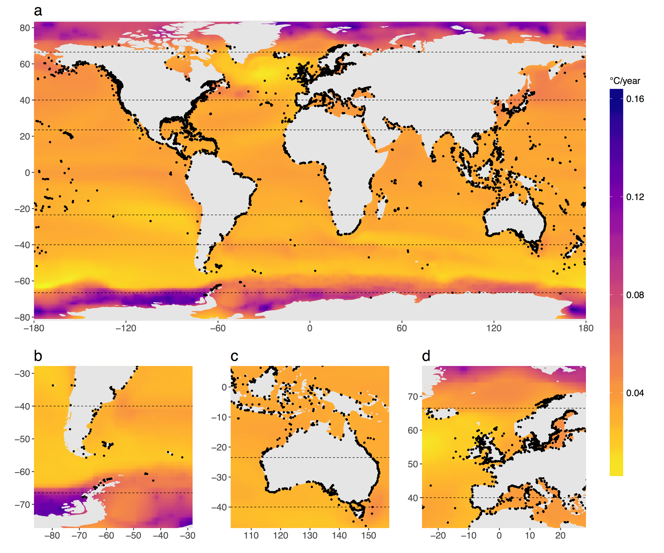

**Figure 1. Patterns of projected ocean warming.** Annual warming rates (°C/year) are based on CMIP5 ensemble model under the RCP 8.5 emissions scenario, 2006-2100. Black dots are MPAs used in the study.



**Figure 2.** **Latitudinal patterns of the year that environmental conditions will exceed predicted thresholds.** For A & B: Blue circles are fully protected reserves in which thresholds have already been exceeded (in 2017), red circles are reserves that have not, and grey circles are grid cells not in a marine reserve. Black lines are fitted functions from a GAM model that includes a spatial autocorrelation term. C: The year that the Community Thermal Safety Margins (CTSM) will be exceeded for marine ecoregions (blue circles) based on the predicted mean warming rate (RCP 8.5) for all MPAs in each ecoregion (see values in Table S1). The CTSM is the average maximum temperature across the geographical ranges (determined with 2,447 *in situ* surveys by the Reef Life Survey program3) of all species in a community minus the present maximum summertime SST; it is an estimate of how far on average community inhabitants are from their thermal maxima3. The geographic pattern for CTSM emergence (C) is largely driven by the inherent differences among latitudes in the CTSM3 (D, plotted as °C), which is substantially greater for higher latitude ecoregions.

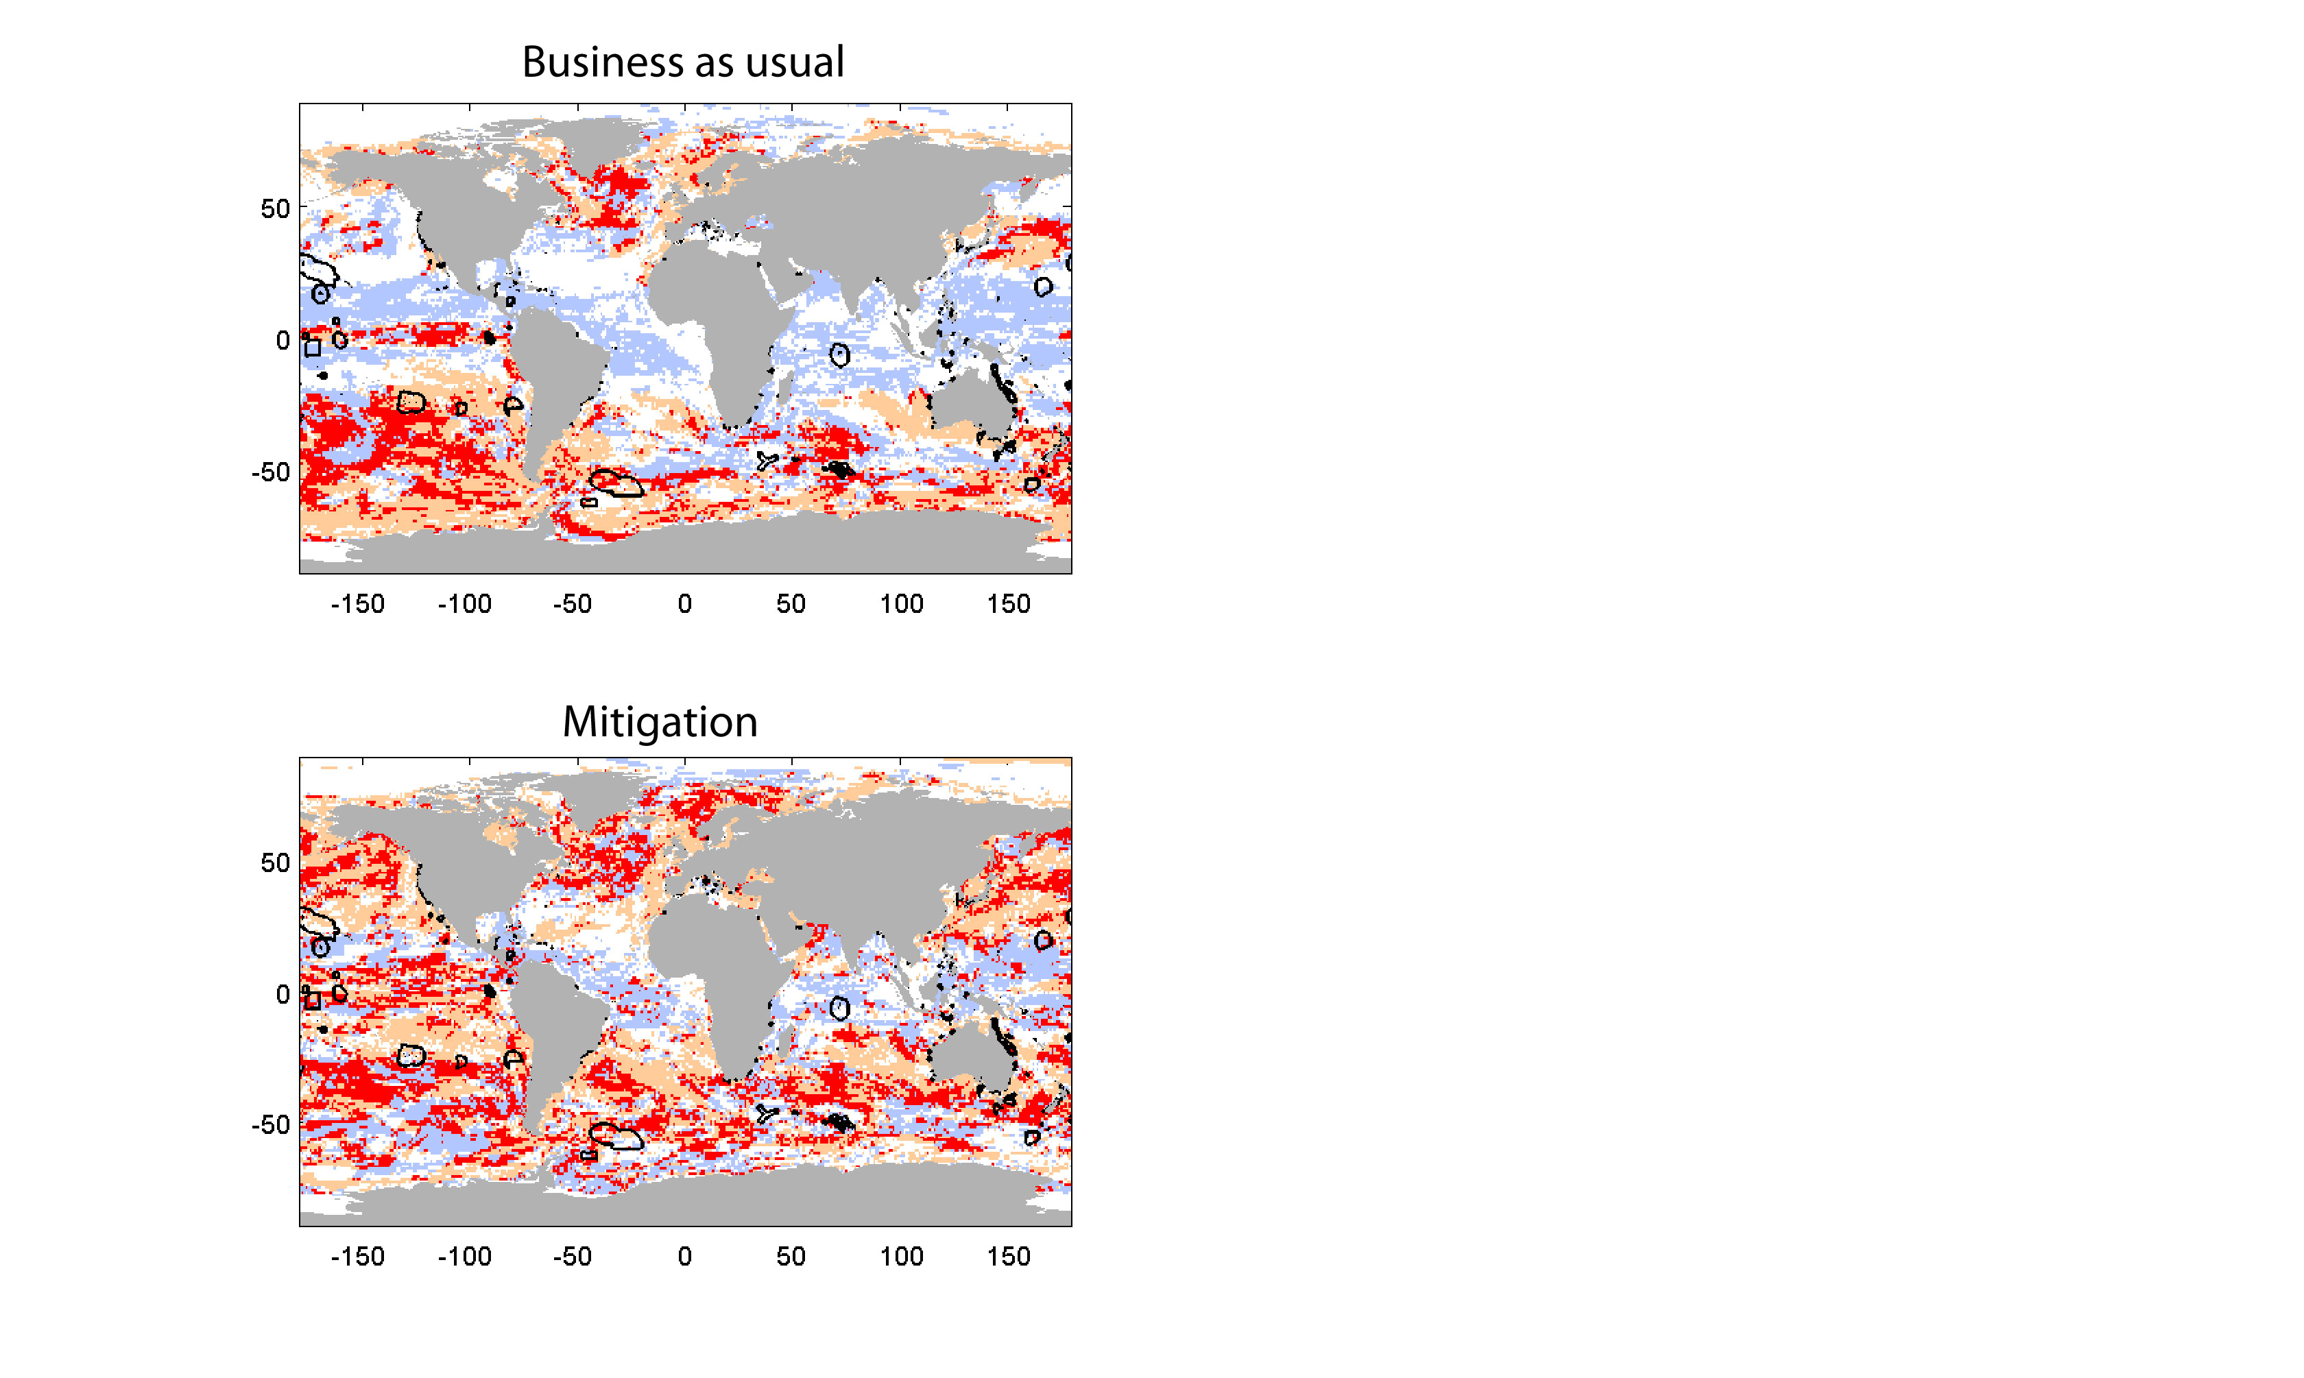 **Figure 3. Spatial distribution of temporary refugia from climate change and current coverage of Marine Protected Areas.** Areas of the ocean for which SST (orange), oxygen concentration (lilac), and both factors (red) emerge after 2050 for RCP 8.5 (top panel) and 4.5 (bottom panel). MPAs are outlined in black.

**Methods**

***Projected temperature values***: Sea Surface Temperature (SST) data were obtained from CMIP5 climate ensembles for both RCP 4.5 and RCP 8.5 at a spatial resolution of 1x1 degree. Cell-specific warming rates for the climate scenarios (RCP 4.5 and RCP 8.5) were calculated as linear rates of change (°C/year) for both the annual mean and annual maximum SST, between 2006 (based on observed current temperatures) and predicted 2100 temperatures. These data were saved as raster files and imported into R Studio (R Core Team 2015) using the R package *raster* (Hijmans 2015). We also examined predicted values from a downscaled model (<5km scale). The downscaling was achieved by adjusting both the annual cycle and mean temperature with observed data from the Pathfinder 5.0 climatology. For complete downscaling methods and models see van Hooidonk et al. (2016). The 1x1 degree data ranged from 90oN to 90oS whereas the downscaled data ranged from 45oN to 45oS. Because of the geographic restriction of the downscaled data, it was used only to validate the use of 1x1 degree resolution data for the global analysis. This was done by comparing projections between the two datasets within the overlapping geographic extent and testing for bias along a latitudinal gradient (Table S2, Fig. S3). Although projections are very similar, there is minor bias across latitudes between the native and downscaled models: the downscaling procedure seems to produce projections that favor faster warming in the southern hemisphere while the native 1x1 models favor faster warming in the northern hemisphere (between 45N and 45S). All data and R code is archived at GitHub: https://github.com/johnfbruno/MPAs_warming

**Table M1.** Comparison of projected SST warming rates (mean annual SST °C / year ± 1 SD) based on based on the native large-grain native CMIP5 simulation ensembles and downscaled values in 5196 tropical and subtropical Marine Protected Areas for two different emission scenarios (RCP 8.5 and 4.5).

|  |  |  |
| --- | --- | --- |
| Scenario | Native model | Downscaled model |
| RCP8.5 | 0.033±0.004 | 0.028±0.05 |
| RCP4.5 | 0.014±0.001 | 0.014±0.002 |

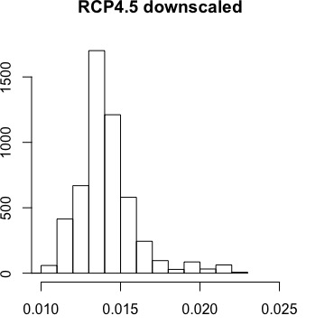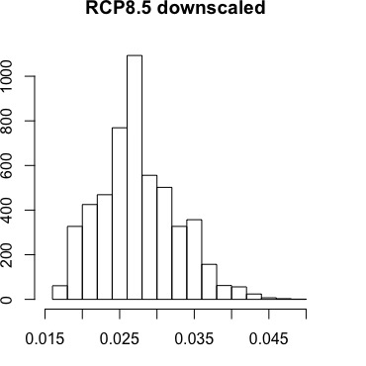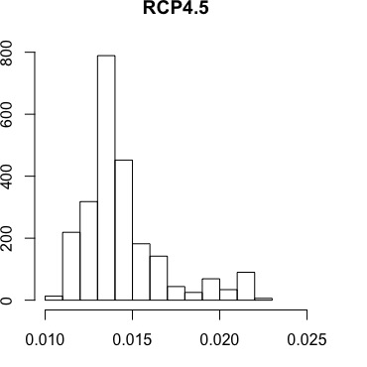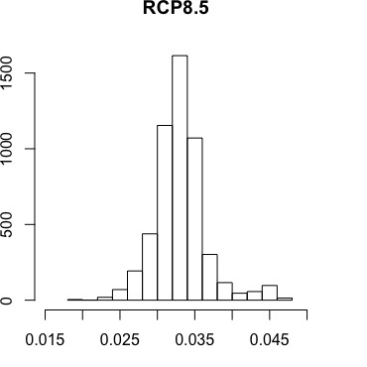

**Figure M1.** Count histograms comparing projected SST warming rates (°C / year) based on the large-grain native CMIP5 simulation ensembles (top panels) and downscaled values (bottom values) in 5196 tropical and subtropical Marine Protected Areas for two different emission scenarios.



**Figure M2.** Comparison of projected SST warming rates (°C / year, 2006-2100 for RCP 8.5) from the large-grain native CMIP5 simulation ensembles and downscaled values, i.e., plotting downscaled projections – native model projections. Made with the levelplot function from the rasterVis package in R.

***MPA locations:*** Coordinates and information for Marine Protected Areas (MPAs) in the world’s oceans were provided by the Marine Conservation Institute, based on a database provided by the UNEP-WCMC and IUCN:

Marine Conservation Institute. (2016). MPAtlas. Seattle, WA. [www.mpatlas.org](http://www.mpatlas.org)  [Accessed Sept 2016] – based on data provided by UNEP-WCMC and IUCN.

UNEP-WCMC and IUCN (2016), Protected Planet: [The World Database on Protected Areas (WDPA) [On-line], Cambridge, UK: UNEP-WCMC and IUCN. Available at: [www.protectedplanet.net](http://www.protectedplanet.net).

Climatic data were extracted from the raster cell closest to the centroid of the spatial polygon for each MPA, and the distance between the raster value and centroid was measured. A downscaled SST raster from Bio-ORACLE (Tyberghein et al. 2012) was used as a land mask for the CMIP5 ensemble data to filter out unwanted MPA coordinates. To prevent the analysis from including both freshwater MPAs, such as ones in the Great Lakes, and MPAs with incorrectly labelled coordinates, extracted cells greater than 50 km away from the MPA centroid were removed from the analysis. The extracted temperature data were then stratified into four groups: 1) polar, ranging from 66.5° to 90° latitude (n=166); 2) temperate, ranging from 40° to 66.5° latitude (n=2738); 3) subtropical, ranging from 23.5° to 40° latitude (n=2738); and tropical ranging from -23.5 oS to 23.5 oN across the equator (n=2458). All analyses were also run as a global composition of MPAs (n=8236) as well as the smaller subset of no-take reserves (n=309). These groups were analyzed for both RCP 8.5 and RCP 4.5 climate scenarios. The rate of change in SST at the sites of MPAs was compared to the background rate of change. This comparison was done for each of the four geographic strata and globally.

***Time of Emergence (ToE) calculations:*** The ToE estimates are taken from Henson et al. (2017); a summary of the approach is given here. ToE is calculated for the annual maxima of SST and the annual minima of thermocline average oxygen concentration. Trends in SST and oxygen are calculated using a generalized least squares model with a first-order autoregressive error term. The time series of annual extrema in the conjoined historical and warming scenario (RCP8.5) runs is created. An inflection point is then identified by calculating the cumulative sum of the gradient in the time series and finding the year when it exceeds zero (for a negative trend) or drops below zero (for a positive trend) for the remainder of the time series. The trend in the time series is then calculated from the inflection point forward to 2100. The natural variability (i.e. noise) is defined using a 100-year section of the model’s control run as one standard deviation in the annual extrema time series. The time of emergence is then defined as:

$$ToE=(2 . noise)/trend$$

Any values of ToE that exceed 2100 are excluded from the analysis.

***Community Thermal Safety Margins (CTSM) analysis:***

**Literature Cited for the Methods**

Hijmans, RJ (2015). raster: Geographic Data Analysis and Modeling. R package version 2.4-20. <http://CRAN.R-project.org/package=raster>

R Core Team (2015). R: A language and environment for statistical computing. R Foundation for Statistical Computing, Vienna, Austria. URL https://www.R-project.org/.

Tyberghein L, Verbruggen H, Pauly K, Troupin C, Mineur F, De Clerck O (2012) Bio-ORACLE: a global environmental dataset for marine species distribution modelling. Global Ecology and Biogeography, 21, 272–281.

van Hooidonk RJ, Maynard J, Tamelander J et al. (2016) Local-scale projections of coral reef futures and implications of the Paris Agreement. Scientific Reports, 6, 39666.

**Table S1.** Meanprojected warming rates (SST °C / year) of MPAs in different marine ecoregions under the RCP 8.5 scenario, based on CMIP5 simulation ensembles. N=number of MPAs per ecoregion.

|  |  |  |
| --- | --- | --- |
| Ecoregion | Rate | N |
| Adriatic Sea | 0.042 | 2 |
| Bassian | 0.033 | 17 |
| Bismarck Sea | 0.032 | 3 |
| Bounty and Antipodes Islands | 0.028 | 2 |
| Campbell Island | 0.023 | 1 |
| Cape Howe | 0.031 | 8 |
| Carolinian | 0.032 | 3 |
| Central New Zealand | 0.033 | 1 |
| Chagos | 0.033 | 1 |
| Coral Sea | 0.030 | 4 |
| Cortezian | 0.033 | 2 |
| East Caroline Islands | 0.035 | 8 |
| Easter Island | 0.030 | 1 |
| Eastern Caribbean | 0.032 | 5 |
| Eastern Galapagos Islands | 0.032 | 1 |
| Exmouth to Broome | 0.028 | 5 |
| Fernando de Naronha and Atoll das Rocas | 0.031 | 1 |
| Fiji Islands | 0.030 | 9 |
| Floridian | 0.031 | 1 |
| Great Australian Bight | 0.029 | 1 |
| Greater Antilles | 0.031 | 26 |
| Gulf of Maine/Bay of Fundy | 0.035 | 2 |
| Hawaii | 0.031 | 16 |
| Houtman | 0.027 | 2 |
| Leeuwin | 0.027 | 1 |
| Line Islands | 0.031 | 2 |
| Lord Howe and Norfolk Islands | 0.025 | 3 |
| Macquarie Island | 0.024 | 2 |
| Manning-Hawkesbury | 0.027 | 4 |
| Mariana Islands | 0.030 | 7 |
| Marshall Islands | 0.032 | 1 |
| Natal | 0.031 | 1 |
| Ningaloo | 0.029 | 1 |
| Northern California | 0.036 | 42 |
| Northern Gulf of Mexico | 0.032 | 1 |
| Oregon, Washington, Vancouver Coast and Shelf | 0.037 | 12 |
| Papua | 0.030 | 1 |
| Phoenix/Tokelau/Northern Cook Islands | 0.036 | 1 |
| Prince Edward Islands | 0.024 | 1 |
| Puget Trough/Georgia Basin | 0.035 | 13 |
| Saharan Upwelling | 0.033 | 1 |
| Sahelian Upwelling | 0.033 | 1 |
| Samoa Islands | 0.033 | 3 |
| Seychelles | 0.034 | 3 |
| Shark Bay | 0.029 | 3 |
| Solomon Sea | 0.031 | 1 |
| South Australian Gulfs | 0.027 | 8 |
| South European Atlantic Shelf | 0.042 | 1 |
| South Orkney Islands | 0.057 | 1 |
| Southern California Bight | 0.034 | 20 |
| Southern Cook/Austral Islands | 0.028 | 4 |
| Southern Gulf of Mexico | 0.032 | 1 |
| Tweed-Moreton | 0.026 | 6 |
| Virginian | 0.034 | 7 |
| Western and Northern Madagascar | 0.024 | 1 |
| Western Bassian | 0.032 | 8 |
| Western Caribbean | 0.033 | 9 |
| Western Mediterranean | 0.042 | 11 |
| Western Sumatra | 0.035 | 1 |

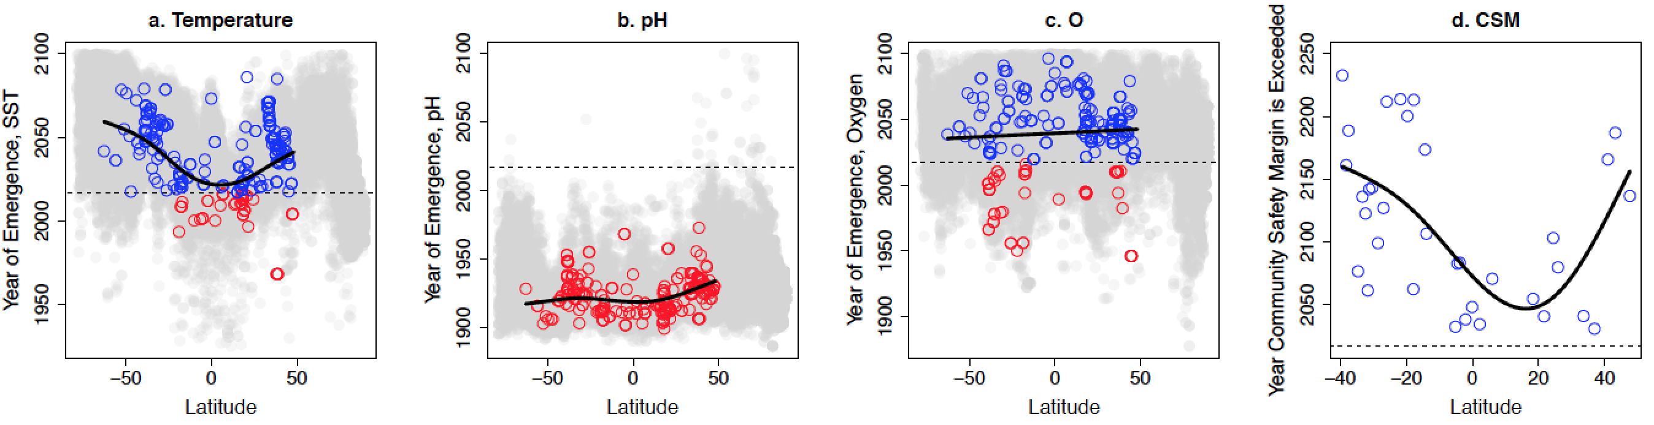

**Figure S1.** Latitudinal variation of the year ocean pH exceeded natural variability (the year of emergence) for fully protected reserves (red circles). Note for all reserves thresholds have already been exceeded. Grid cells not in a marine reserve are grey circles. Black line is a fitted function from a GAM model that includes a spatial autocorrelation term.

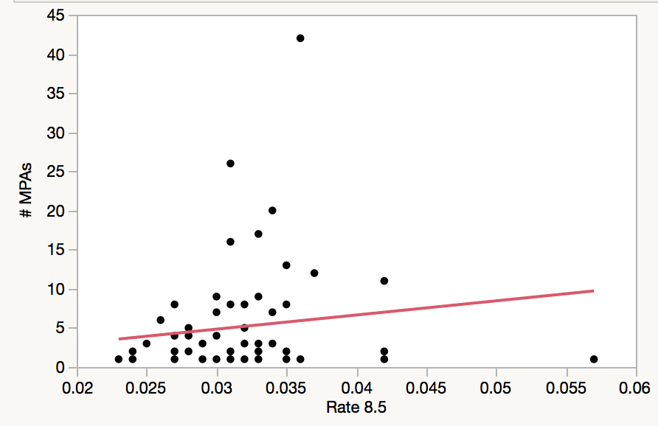

**Figure S2.** Relationship between the projected warming rate of marine ecoregions under RCP 8.5 (which is based on the average warming rate of MPAs in a given ecoregion) and the number of MPAs in each ecoregion. There is no statistically significant relationship between the rate of warming and number of MPAs (p=0.32 for a linear regression).